|  |  |
| --- | --- |
| No. of Pages | **4** |
| No. of Questions | **3** |

**Department of Computer Science and Engineering**

**MIDTERM EXAMINATION SUMMER 2014**

**CSE421: Computer Network**

**Total Marks: 45 Time Allowed: 50 minutes**



* Answer ALL **THREE (3)** questions
* Figure in bracket [] next to each question indicates marks for that question



**Question 1**

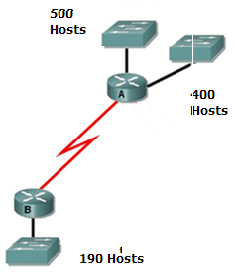

**Figure no. 1**

1. Suppose a company is given a block **200.20.24.0/21.** But you need three more sub networks for your organization and one more for the WAN Link as shown in figure no. 1. Show how you can have 4 more subnets out of the original network address as per host requirements. Do not forget to show basic calculations. [8 marks]
2. A routing table entry is shown as:

**S 172.16.1.0/24 [1/0] via 172.16.2.2**

What is the meaning of the [1/0]? [3 marks]

1. Differentiate between Static and Default Routes. [4 marks]

**Question 2**

1. State two features of Distance Vector that is different from Link State Routing Protocols. [3 marks]

|  |  |  |  |  |
| --- | --- | --- | --- | --- |
| **Node x Table** | | |  |  |
|  | **x** | **y** | **z** | **w** |
| **x** | 0 | 2 | ∞ | 6 |
| **y** | ∞ | ∞ | ∞ | ∞ |
| **z** | ∞ | ∞ | ∞ | ∞ |
| **w** | ∞ | ∞ | ∞ | ∞ |

**Figure no. 2**

1. For the above figure no. 2, the table represents the routing table of Router X initially. Router X receives updates from Y and W routers. All routers are running Distance Vector algorithm. What will be the status of routing table of Router X be? (Use Dx(y) = min{c(x,y) + Dy(y), c(x,z) + Dz(y)} for explaining your answer) [4 marks]
2. Router Edmonton is running RIPv2 shown in figure no. 3. Summarize the following networks shown at Edmonton so that it can advertise only one summarized network in its updates to Vancouver instead of the 8 separate networks. Show calculations. [4 marks]

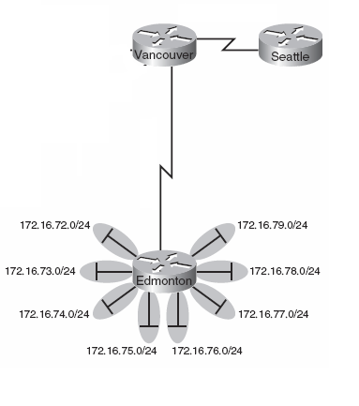

**Figure no. 3**

1. Refer to figure no. 4 below, R1 sends an update to R2 and R3. Next R2 sends an update with information regarding 194.20.20.0/24 network to R3. Will R3 send the same information regarding 194.20.20.0/24 network back to R1? Explain yes or no. [4 marks]

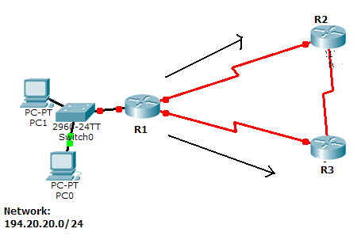

**Figure no. 4**

**Question 3**

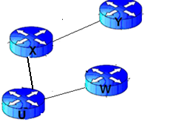

**Figure no. 5**

1. Link state routing protocol uses Dijkstra’s algorithm. Now using Dijkstra’s algorithm, compute the shortest path from Wto all other remote networks shown in figure no.5. Use the table provided. [ 5 marks]

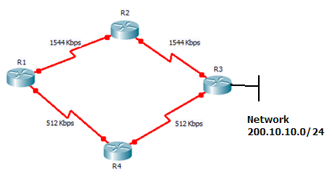

Partial output from R1

**O 200.10.10.0/24 [110/129] via 193.10.10.10, 00:05:14, Serial 0/0**

**[110/129] via 194.10.10.10, 00:06:14, Serial 0/1**

**Figure no. 6**

1. In the routing table of Router1 shown above in figure no. 6, it has two equal cost paths to the network 200.10.10.0/24 attached to R3. Does this correctly reflect the diagram above? If not, how should we rectify it? [4 marks]

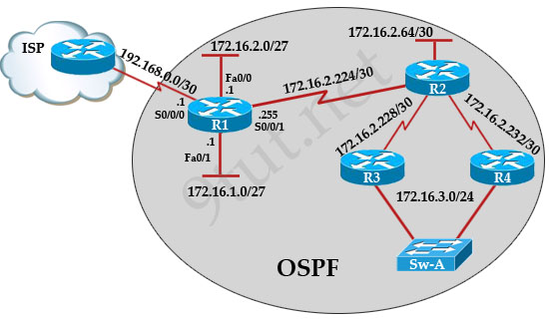

**Figure no. 7**

1. Router R1 as shown in figure no.7 has been configured with a default route to the ISP. Routers R2, R3 and R4 are using OSPF. How can routers R2, R3 and R4 learn the default route from R1? [3 marks]
2. In the above figure no.7, Router R2 is not forming neighbors with Routers R3 and R4. What could be the probable reasons? [3 marks]

**THE END**